THE ALISON HASKELL AWARD
FOR EXCELLENCE IN HERPETOFAUNAL CONSERVATION

Nomination Form

About the Award: This Award is presented annually by Partners in Amphibian and Reptile Conservation (PARC), in memory of Alison Haskell (1956 – 2006), who was the first National Federal Coordinator for PARC, to recognize an individual who conducts work in an active PARC area (Fig. 1) and exemplifies extraordinary commitment to herpetofaunal conservation, as did Alison. Award recipients will receive $1,000 in cash and an engraved, commemorative plaque. Please visit http://parcplace.org/about/parc-awards/the-alison-haskell-award/ to learn more about the award, and about past recipients and their work.

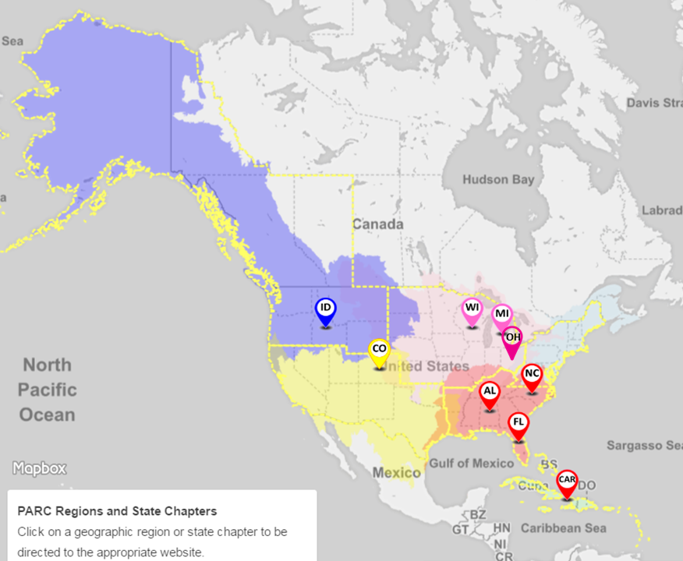
This map does not contain active links. To see the map with active links, visit http://arcplace.org/parcplace/locate.html

Figure 1. Map showing active PARC areas outlined in yellow.
This map does not contain active links. To see the map
with active links, visit http://parcplace.org/parcplace/locate.html

Award Criteria:

Nominees must observe and uphold the highest standards of scientific integrity and professional behavior, and must uphold PARC’s Code of Ethics and Meeting Code of Conduct.

Nominees may be submitted by third parties, or self-submitted, and must meet one or more of the following criteria:

- Any person who has displayed exemplary commitment to building or strengthening partnerships: (1) with stakeholders outside the individual’s agency or organization, or (2) with non-traditional stakeholders (i.e., stakeholders with whom an individual or agency did not previously interact), or (3) that promoted efficiencies in herpetofaunal conservation through partnerships.
- Any person who has displayed distinguished career-long contributions to partnerships and herpetofaunal conservation.
- Special consideration will be given to any person who has exhibited tenacious effort, leadership and professionalism in a manner that is inspiring to their peers, and who has been overlooked by other means of acclaim.

Nominee:

Name:
Mailing Address (including City and State):
PARC Area(s) in Which the Nominee Conducts Work:
Phone:
Email:

Nominated by:

Name:
Address:
PARC Region:
Phone:
Email:

Nomination

**Please adhere to the word and page limits, or the nomination will not be considered.

- In 100 words or less, describe how the nominee has fostered herpetofaunal conservation.

- In 300 words or less, provide examples of how the nominee has displayed an exemplary commitment to building or strengthening partnerships.

- In 150 words or less, describe how such partnerships significantly improved herpetofaunal conservation.

- [OPTIONAL] Using no more than 4 pages total, you may provide a letter or letters of support. This page limit is inclusive of signatures (i.e., you cannot submit a 4-page letter with 2 pages of signatures for 6 pages total). Required format: 12-point font and 1-inch margins.

Please note that nominees are evaluated on the merit of the nomination, not on the number of letters of support or the number of supporting signatures per each letter.

Submission: Please send the completed nomination form along with any supplemental information to haskellaward@parcplace.org.

***Deadline: On or before Friday, Nov 2, 2018.***

Nominations received after this date and incomplete forms will not be considered. The award winner will be notified by or before mid-January 2019.

Thank you for submitting this nomination! It is a great way to show appreciation for the work being done by a colleague!!

Note: Current voting members on PARC’s Joint National Steering Committee are not eligible for nomination. In Fall of 2018, those members are:

JNSC MEMBER | PARC ROLE | TITLE AND AFFILIATION
Executive Committee
Michelle Christman | JNSC Senior Co-chair | Fish and Wildlife Biologist, US Fish & Wildlife Service, New Mexico Ecological Services Field Office
Chris Petersen | JNSC Junior Co-chair | DoD PARC National Program Representative
Vacant | National States Coordinator | Program Manager, Amphibians & Reptiles, and Invasive Species, Association of Fish & Wildlife Agencies
Jen Williams | National Federal Coordinator | PARC National Federal Coordinator, hosted by National Park Service
Midwest PARC
Allison Sacerdote-Velat | Senior Co-chair | Curator of Herpetology, Chicago Academy of Sciences, Dept of Biology
Bob Brodman | Junior Co-chair | Associate Professor of Biology, Buena Vista University
Northeast PARC
Noelle Rayman-Metcalf | Senior Co-chair | Endangered Species Biologist, US Fish & Wildlife Service, New York Field Office
Anne Stengle | Junior Co-chair | Graduate Student in Organismic & Evolutionary Biology at UMass Amherst
JNSC MEMBER | PARC ROLE | TITLE AND AFFILIATION
Northwest PARC
Katy Weil | Senior Co-chair | Senior Management Analyst, Oregon Metro Parks and Nature, Conservation Program
Vacant | Junior Co-chair
Southeast PARC
Katie Parson | Senior Co-chair | M.S. Student, University of Georgia
Becca Cozad | Junior Co-chair | Research Biologist, Nokusa Plantation
Southwest PARC
Melissa Amarello | Senior Co-chair | Co-Founder and Director of Education, Advocates for Snake Preservation
Cristina Jones | Junior Co-chair | State Turtle Biologist for the Arizona Game and Fish Dept
DoD PARC
Dave McNaughton | DoD PARC Representative | Assistant Wildlife Program Manager, Pennsylvania Dept of Military and Veterans Affairs
At-large Members
Jessica Homyack | Industry Representative | Manager, Environmental Research North for Weyerhaeuser Co.
Michael Starkey | Non-governmental Organization Representative | Co-Founder and Executive Director, Save the Snakes
Shelly Grow | Zoos and Aquariums Representative | Director of Conservation Programs, Association of Zoos & Aquariums
Federal Government
Dave Hu | Federal Agencies Steering Committee Senior Co-chair | National Fisheries Biologist, Bureau of Land Management
Will Fields | Federal Agencies Steering Committee Junior Co-chair | Ecologist, U.S. Army Engineer Research and Development Center

JNSC MEMBER | PARC ROLE | TITLE AND AFFILIATION
State Government
Catherine Sparks | Association of Fish and Wildlife Agencies Amphibian and Reptile Conservation Committee Vice Chair | Assistant Director, Bureau of Natural Resources, Rhode Island Dept of Environmental Management
Thomas Eason | Association of Fish and Wildlife Agencies Amphibian and Reptile Conservation Committee Chair | Assistant Executive Director, Florida Fish and Wildlife Conservation Commission

